**Report Lab2**

**Object Oriented Programming**

2. Problem Statement of AIMS Project

3. Use case diagram

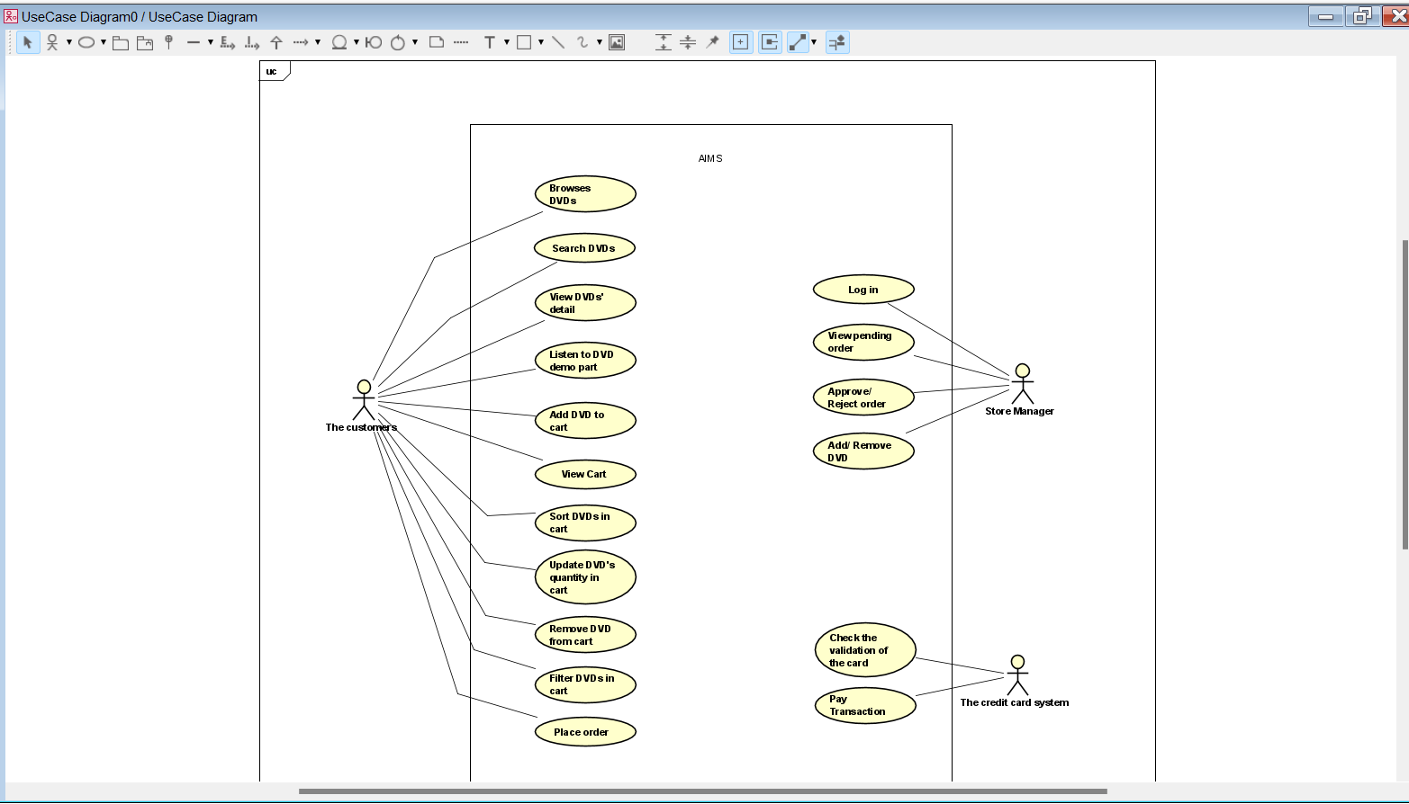

4. UML Class Diagram for use cases related to cart management

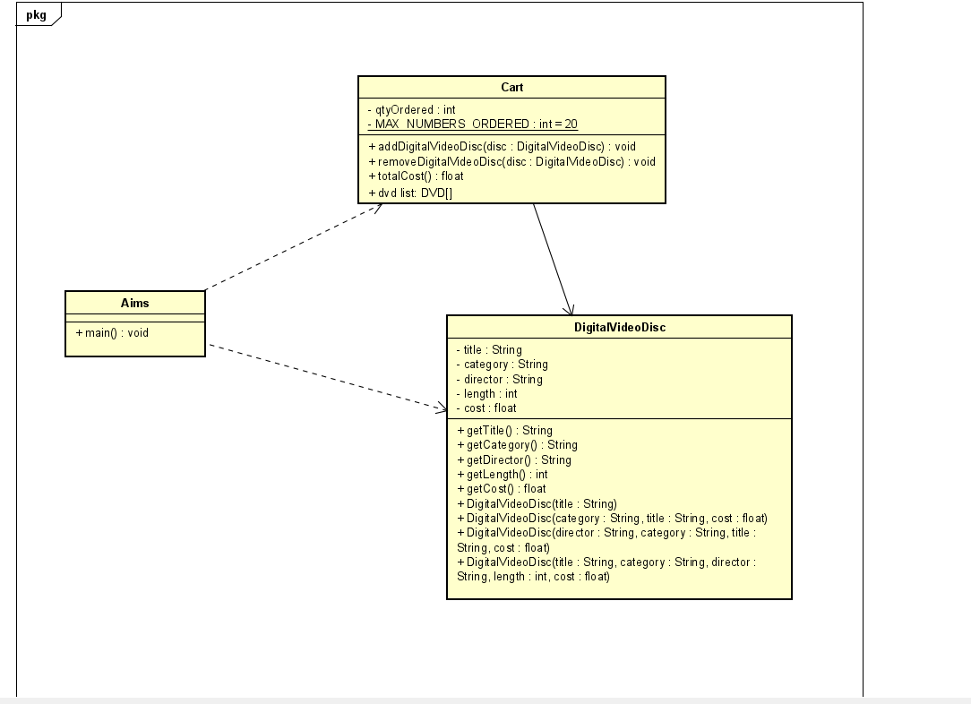

5. Create Aims class

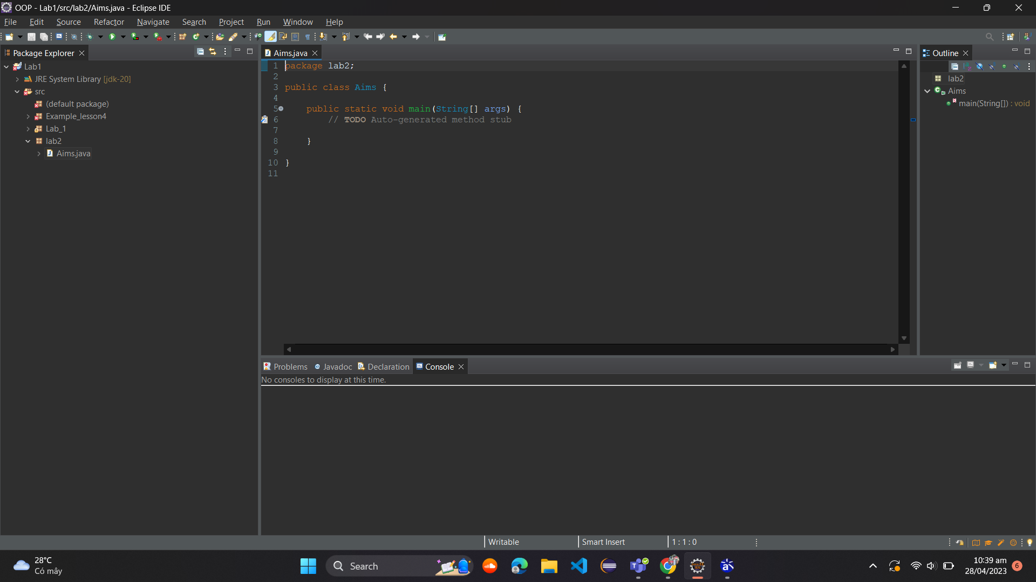

6. Create the DigitalVideoDisc class and its attributes

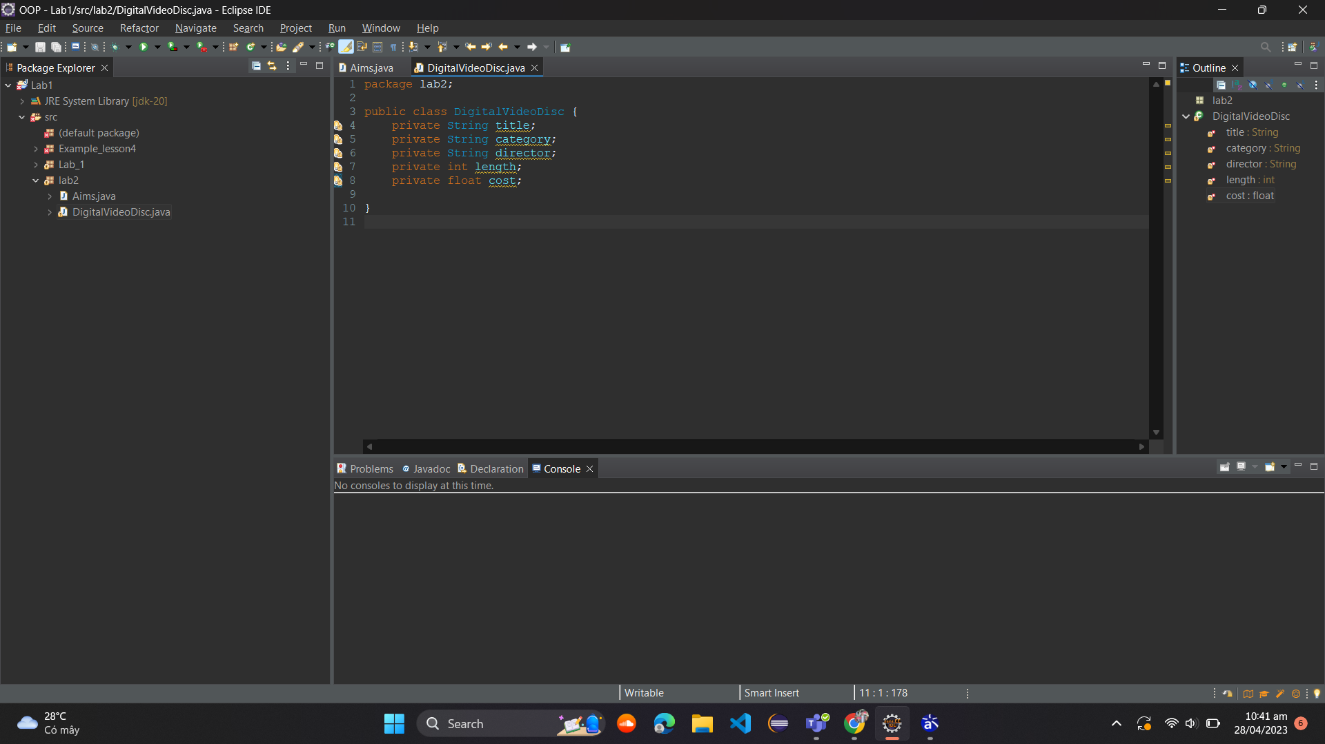

7. Create accessors and mutators for the class DigitalVideoDisc

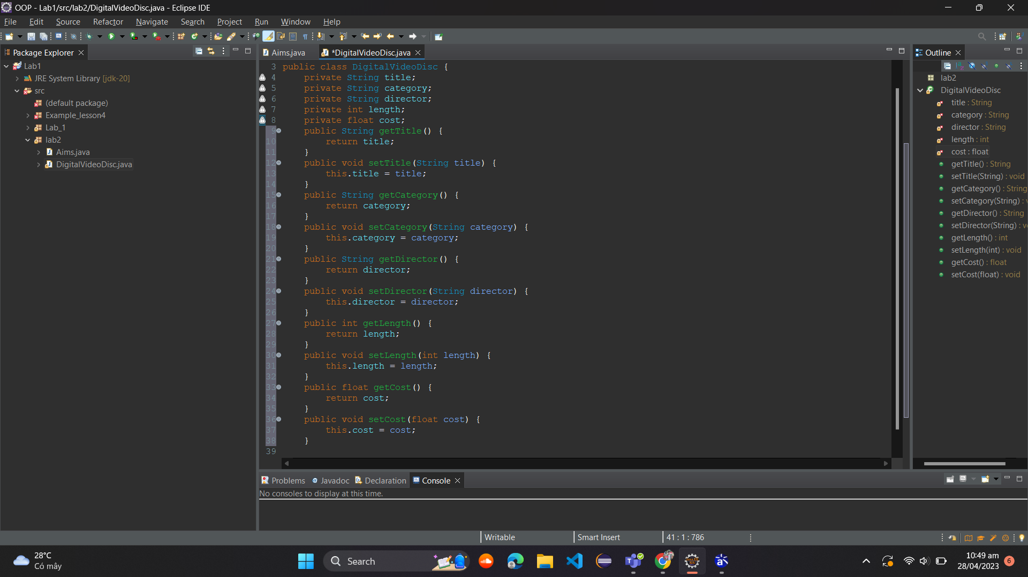

**Reading Assignment**: When should accessor methods be used?

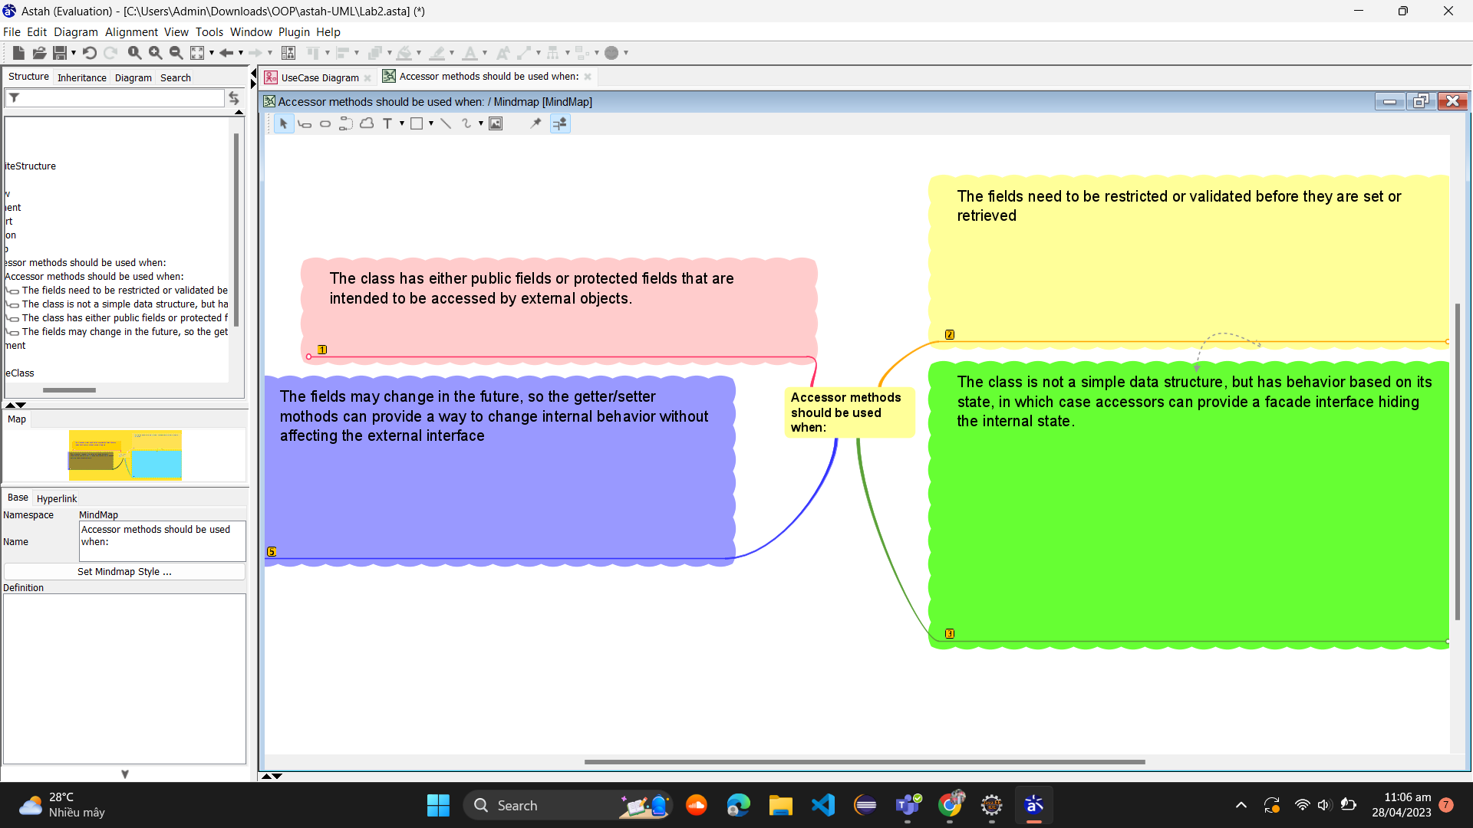

8. Create Constructor method

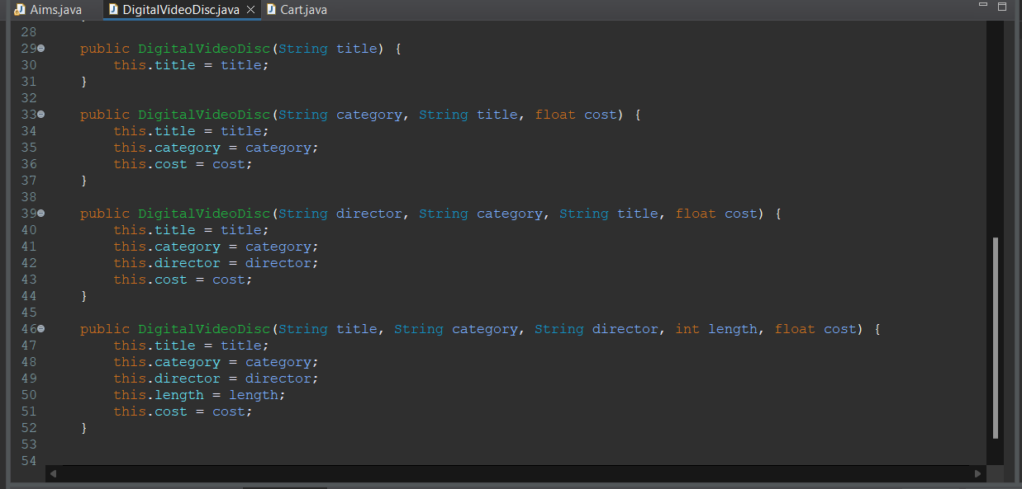

9. Create the Cart class to work with DigitalVideoDisc

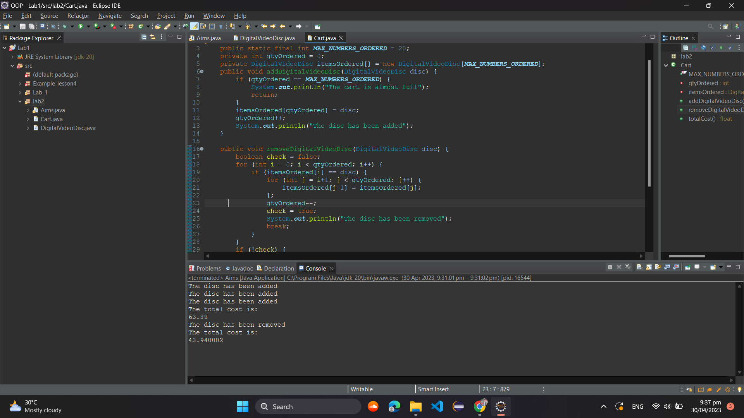

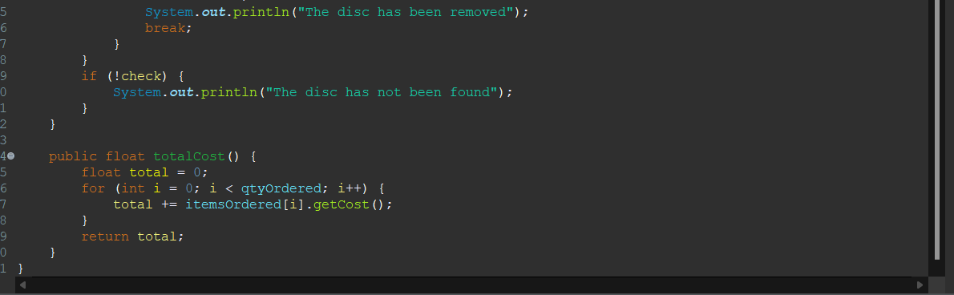

10. Create Carts of DigitalVideoDiscs

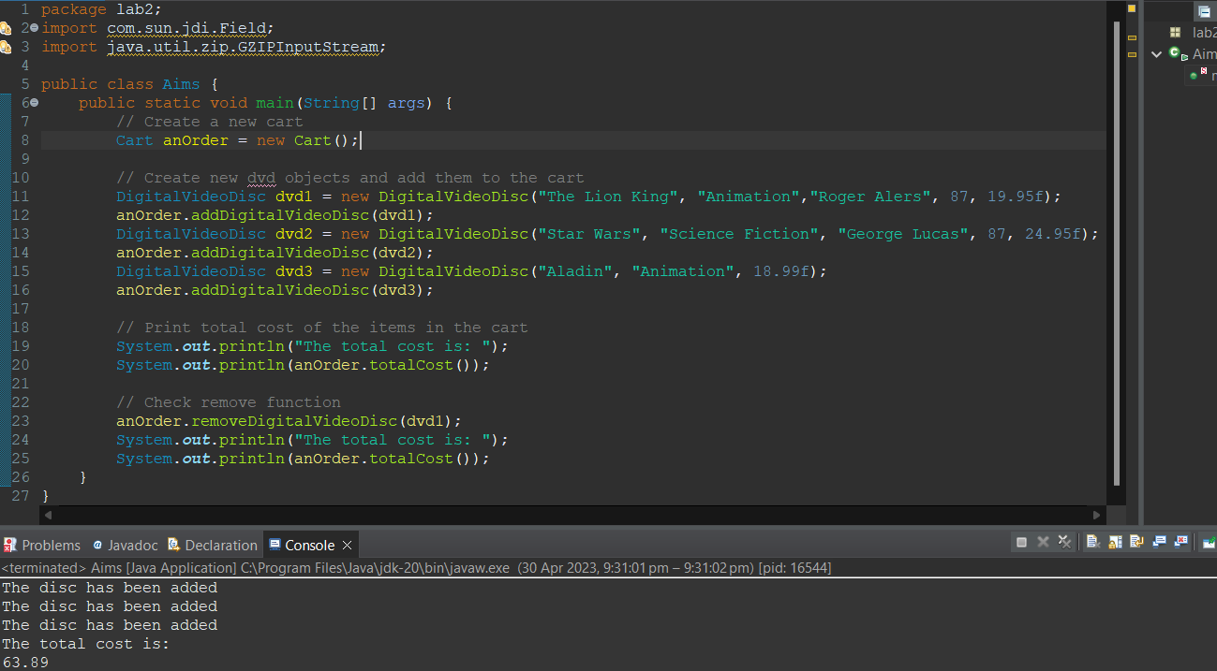

11. Removing items from the cart

